Assignment 2
Name: Amit Kumar
ID: 2024UCP162
Batch: A3

Q3.
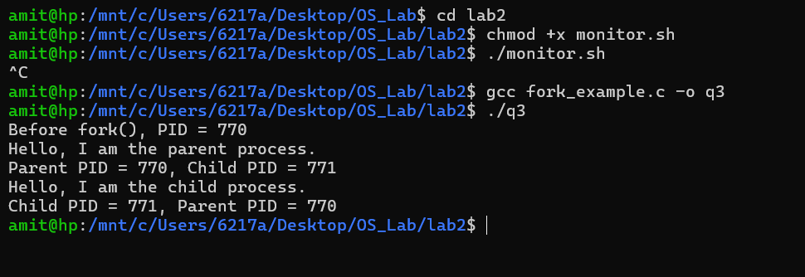
The fork() system call creates a new child process by duplicating the calling process. The output shows both the parent and child processes executing concurrently, each successfully printing their respective Process IDs (PIDs) and identifying themselves.

Q4.
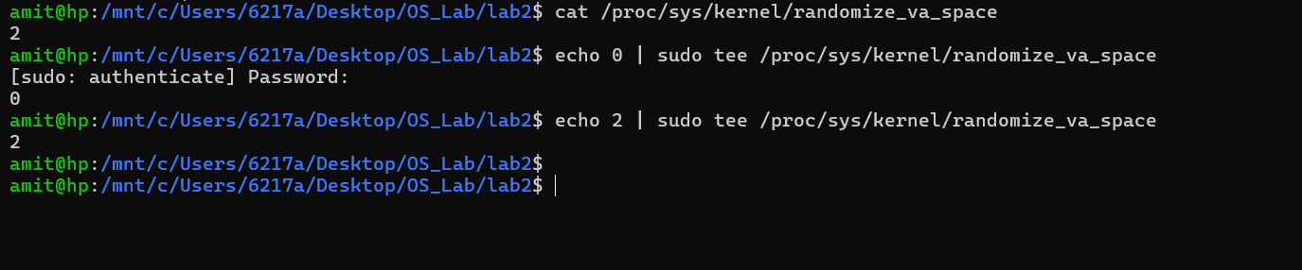
Address Space Layout Randomization (ASLR) is a security feature that randomizes memory addresses. The commands modify the /proc/sys/kernel/randomize_va_space file to check its current status, disable it (by writing 0), and re-enable full randomization (by writing 2).

Q5.
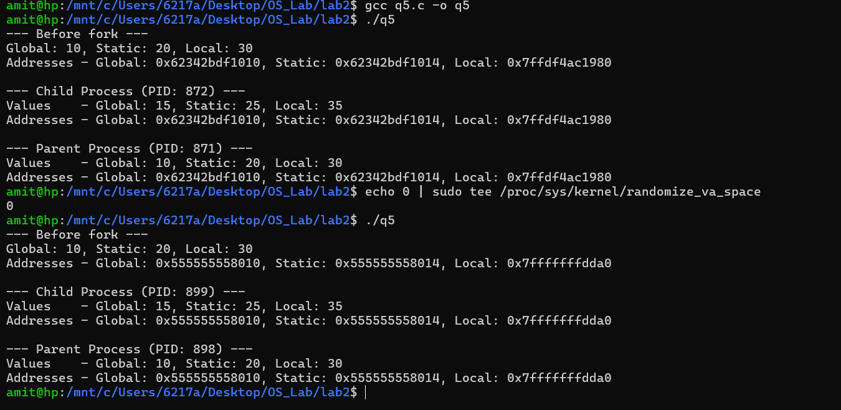
The observation indicates that global, local, and static variables remain unshared between the parent and child processes; upon duplication, the child obtains a distinct, isolated instance of the parent's memory space. With Address Space Layout Randomization (ASLR) deactivated, virtual memory addresses persist consistently over various executions. Conversely, activating ASLR causes these addresses to vary with each run, though the child continues to inherit an exact replica of the parent's memory configuration during the fork() operation.

Q6.
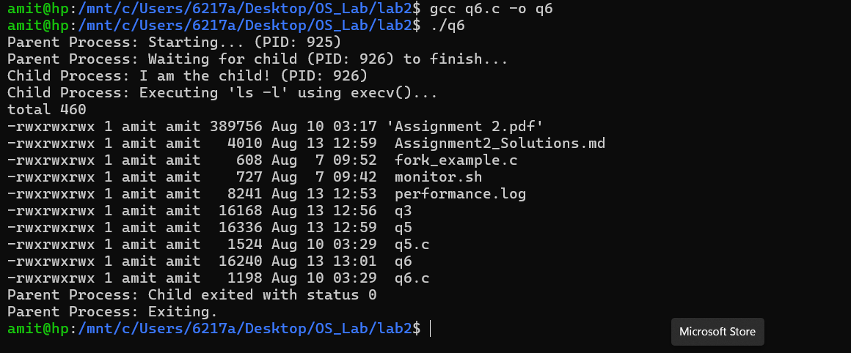
The program demonstrates the integration of process generation and task execution. Through the fork() system call, the parent process initiates a child, which subsequently invokes execv() to overwrite its memory image with the 'ls -l' utility. Meanwhile, the parent utilizes wait() to remain in a suspended state, ensuring it only resumes once the child has completed its directory listing operation.

